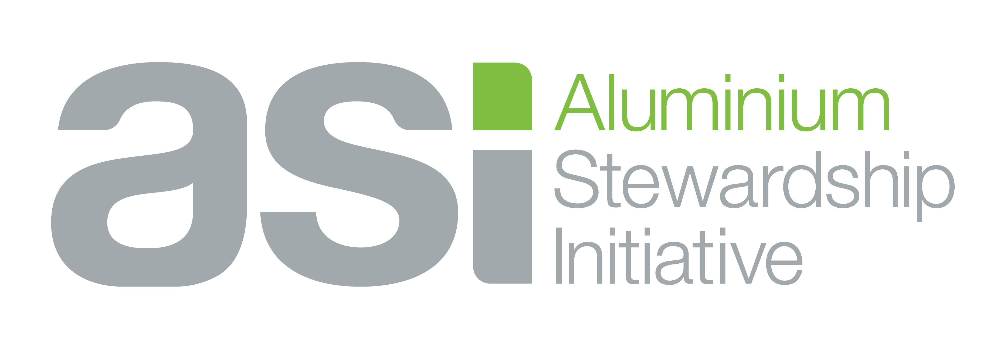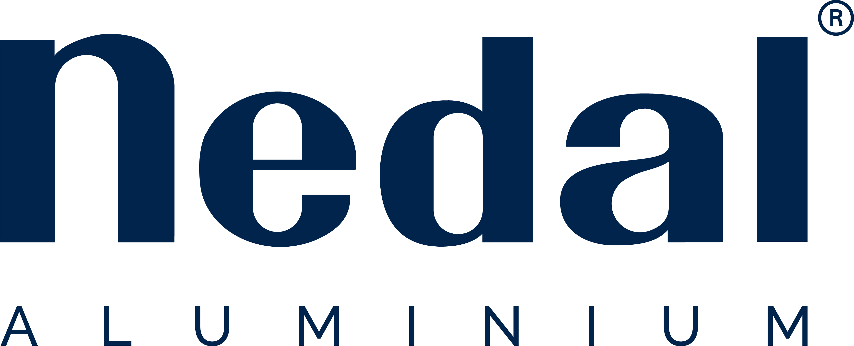
Sustainability Report 2022
Nedal Aluminium B.V.
Index:
1. Environmental, Social and Governance Policy 2
2. Responsible sourcing 2
3. Environmental and social impact assessments 2
4. Human rights Impact Assessment 2
5. Non compliance and liability 2
6. Payments to Governments 3
7. Stakeholder Complaints, Grievances and Request for Information 3
8. Environmental Life Cycle Assessment 3
9. Disclosure of GHG Emissions and Energy Use 4
10. GHG Emissions Reduction Plans 4
11. Emissions to air 5
12. Discharges to water 5
13. Public disclosure of Spills and Leakages 6
14. Waste Management and Reporting 6
15. Water Assessment and Disclosure 7
16. Biodiversity Management 7
17. Human Rights Due Diligence 8
18. Indigenous Peoples 9
19. Affected Populations and Organisations 9
20. Occupational Health and Safety Management System 10
21. Forced Labour (Modern Slavery) 11

1. Environmental, Social and Governance Policy
See Code of Conduct:

2. Responsible sourcing
See Code of Conduct:

3. Environmental and social impact assessments
In case of new projects or major changes an environmental and social impact assessment will be conducted:
- Health and safety
- Human rights
- Environmental: Influence on stakeholders and nature
- Current legislation and zoning plan

4. Human rights Impact Assessment
For new projects or major changes to existing facilities a human rights impact assessment, including a gender analysis will be conducted.

5. Non compliance and liability
At the time of publication, there are no pending legal violations and associated fines, judgements, penalties or non-monetary sanctions.

6. Payments to Governments
Nedal maintains a good professional relationship with all the involved authorities and relies on good dialogue and transparency. During the reporting period, Nedal did not make any payments to governments that exceed legal requirements.

7. Stakeholder Complaints, Grievances and Request for Information
See Code of Conduct:
The link to the anonymous reporting channel can be found on the Nedal website (Quality).

8. Environmental Life Cycle Assessment
For the extrusion and production of lighting columns a Life Cycle Analysis has been performed, by the Climate Neutral Group standard, certified by Preferred by Nature: https://www.climateneutralcertification.com
Scope: Raw material, transport of billets, extrusion, production of lighting columns and transport to customers.
By using a high percentage of recycled aluminium, the CO2-footprint is kept low: The remainder of the CO2-footprint is being off-set by contribution to certified CO2-saving projects.
For the Dutch National Environmental Database a certified LCA for lighting columns was set up according to: ISO 14040/14044 and EN 15804 (+A1/A2).
Scope: Raw material, production, construction, use, end-of-life, resource recovery stage.
A summary of the LCA (EPD) is accessible on the Nedal website.

9. Disclosure of GHG Emissions and Energy Use
2022:
- Total electricity consumption:
Green: 6.671.748 kWh (including lighting columns). Grey: 6.671.748 kWh
Compared to 2021: - 3 % per ton Al
- Total gas consumption (including lighting columns):
1.555.771 m3
Compared to 2021: - 5,7 % per ton Al - Total CO2- GHG Emissions:
Electricity (scope 2): 3.489 ton
Gas (scope 1): 3.243 ton
Off-set (Climate Neutral Group): 2.724 ton
In December 2023 an independent full-emission survey will be conducted

10. GHG Emissions Reduction Plans
Nedal is committed to reduce the GHG-emissions in order to keep the warming of the earth below 1,5 ⁰C.
Targets for the year 2023:
- Reduce the CO2-footprint of the production by 2 %
- Processing a high % of secondary aluminium: more than 60 % of the total.
- Reduce the CO2-footprint of the production/aluminium of lighting columns with a minimum of 25 % in the year 2030 (refence year: 2016). Annual: Min 1,8 %
Means to reduce the CO2-footprint:
- Increasing efficiency of the processes (material yield) by optimizing processes and investments.

- Investments: New efficient cooling towers, new cooling/quenching facilities on the 14-inch press.

11. Emissions to air
2022:
CO2: (scope 1): 3.243 ton.
In December 2023 an independent full-emission to air survey will be conducted

12. Discharges to water
- Water analysis by KWA (central sewer discharge point).
Samples taken on the June, 1st 2023:
Substances | Analysis %  *)
pH | In range
Temperature | 57
Undissolved components | 40
Sulphate | 5,7
Sum Cr, Cu, Ni, Pb, Zn | 5,4
Mineral oil | 0,8
BTEX | < 0,2
PAK (16 EPA) | < 1

*) Measured quantity as % of the maximum allowed quantity according to environmental permit (competent authority) - Total quantity of waste-water (sewer) 2022:
12.049 m3

13. Public disclosure of Spills and Leakages
The measures and safety instructions against spills and leakages are part of the “Emergencyplan Nedal”.
Adequate prevention-measures have been taken:
- Maintenance of extrusion presses and other equipment.
- Liquid tight floors.
- Instructions for the employee’s, how to react in case of spills and leakages.
In the past year, no spills or leakages, with impact on people or environment, did occur.
Information about the “Emergencyplan Nedal” can be obtained:
- Manager Company Emergency Service: woutervandokkum@nedal.nl
- Safety Officer: deanhoedeman@nedal.nl

14. Waste Management and Reporting
Waste management 2022.
Category | Weight (kg)
Paper/Cardboard/Wood/PlasUc | 167.140
Aluminium saw-chips | 68.937
Residual Waste | 200.927
ConstrucUon./DemoliUon | 7.820
Al Grinding (water) | 35.450
Iron | 11.742
Die Steel | 112.900
Hydr. Oil | 47.800
CausUc Soda | 2.515.200
Total | 3.167.916
% Recycled | 90
Hazardous waste:
Caustic Soda 99% is being recycled
Targets reduction for the year 2023:
- Caustic Soda (consumption): - 20 % by not removing aluminium in the die and efficiency improvements.
- Paper/Cardboard, Wood, Plastic: - 5 % By optimizing packaging of profiles.

15. Water Assessment and Disclosure
WaterconsumpBon 2022
All water is supplied by the local waterauthority. |  | m3
Total consumpUon (input): |  | 18.648
DomesUc applicaUons: |  | 2.189
CausUc (Die cleaning): |  | 2.501
Processes (e.g. cooling) |  | 4.098
City Sewer (output) : |  | 12.049
- Reduction of water consumption: See target on use of Caustic Soda.

16. Biodiversity Management
Zoning plan of Nedal (Community of Utrecht January 28th, 2022)
4.8 Biodiversity:
Legal framework
The protection of nature in the Netherlands is enshrined in European and national laws and regulations, which distinguish between species protection and area protection. Species protection in the Netherlands is regulated in the Flora and Fauna Act and area protection in the Nature Conservation Act 1998.
Situation in the plan area:
In the plan area, there are no protected natural monuments or other natural areas included in the Nature Conservation Act 1998. Nor are there any areas or connecting zones within the National Ecological Network. Hooggelegen (business park in Utrecht) does not form part of a national landscape and at a distance of about 6 kilometres lies the Natura 2000 area of the Oostelijke Vechtplassen, in the municipality of Stichtse Vecht.
In the applications for the environmental permits, it has been demonstrated with sufficient accuracy that the emissions of N02 and PMIO to the outside air will be limited sufficiently, so that the effects of the activities to be licensed on air quality do not contribute significantly to the concentration of N02 and PM 10 in the outside air. To safeguard this, the environmental permits are accompanied by regulations that will lead to this goal. In view of the distances to the Natura 2000 area and the limited development possibilities included in the zoning plan, it is likely that this will have no significant effects on the flora and fauna in the nature area. The conservation of the species and/or the conservation objectives of the nature reserve are not at risk.

17. Human Rights Due Diligence
Introduction
This human rights policy describes the human rights standards that must be observed by Nedal and by all its subsidiaries, partnerships, companies or other business associations that are directly or indirectly controlled by Nedal. This includes all employees, directors and persons acting on behalf of Nedal.
All Nedal business partners are expected to comply with the Nedal Supplier Code of Conduct, which sets out the responsibility of business partners to respect all internationally recognized human rights. All Nedal employees are expected to comply with the Nedal Code of Conduct, which sets out the responsibility of employees and all other persons working in and with Nedal to respect all internationally recognized human rights.
Nedal practises an active policy of giving equal opportunities to all, irrespective of gender, sexual orientation, religion, cultural background or other preferences.

See Code of Conduct:
Currently, the Code of Conduct is a draft and is going through the final approval process of the Purso Board of Directors.
More information: https://www.nedal.com/nl/overons/werken-bij-nedal/
Manager HRM: woutervandokkum@nedal.nl

18. Indigenous Peoples
Since the activities of Nedal take place in Utrecht, the Netherlands, the issue of Indigenous people is not applicable.
Regarding our (sub)suppliers, the human rights of all employees including indigenous people are being addressed in the Nedal Supplier Code of Conduct.
The higher-risk suppliers of Nedal (aluminium producers with their supply chain) are all ASIcertified.

19. Affected Populations and Organisations
Nedal sponsored the last years several sportive and other events:

- The Utrecht Marathon. This included hiring a trainer, whereby Nedal employees could follow running training during working hours.
- With the link to health, Nedal sponsored the Roparun, which “runs” from Paris to Rotterdam and whose proceeds benefit the fight against Cancer.
- The Ladiesrun: Nedal set up a care station along the course, where participants can pick up water and any care they need.
- The Utrecht Nedal Nightrun, for a fantastic local event with 4.000 participants.
- The Utrecht Singelloop (5 km) in 2022, most recently run on Sunday 1. October 2023.
- The First Aid and Blind Guide Dogs.
Contacts with the municipality of Utrecht on a regular base (mayor and aldermen, Lage
Weide Industrial Estate, economy board participant) were strengthened by opening the Nedal Charging Square (EV-mobility) inaugurated by the aldermen in Augus 2023 and participation in the Open Energy Day in September 2023.
As a regular habit, Nedal was present at “De Beurs van de Openbare Ruimte”in the Utrecht Trade Fair.

20. Occupational Health and Safety Management System
Nedal is certified regarding:
- ISO 14001: Environment
- ISO 45001: Health and Safety
These systems include:
- Organizational context
- Leadership and worker participation
- Planning
- Support
- Operation
- Performance evaluation
- Improvement
Benchmark with industry-sector (FME) for the year 2022:
% of employees with accident
and therefore more than 1 day sick leave: % sick leave:
Average Industry | Nedal |  | Average industry | Nedal
1,7 | 1,2 |  | 9,7 | 5,9

21. Forced Labour (Modern Slavery)
Indicators of Modern Slavery according to ILO:
- Abuse of vulnerability
- Deception
- Restriction of movement
- Isolation
- Physical and sexual violence
- Intimidation and threats
- Retention of identity documents
- Withholding of wages
- Debt bondage
- Abusive working and living conditions
- Excessive overtime

Actions taken by Nedal to prevent Modern Slavery:
- The HRM-department applies the legislation and the collective bargaining agreement (CAO) to prevent modern slavery.
- By one-point lessons the employees are being informed about their rights.
- Assessment of the employment agency (temporary workers).
- No business connections with companies in countries with high modern slavery risks (according to Walkfree.org).
- Priority: Confirmation by suppliers of the Nedal Code of Conduct Suppliers for higher risk sectors.
- Investigation on Internet for higher risk sector by random sampling.

